**Keyhole Spacecraft KH10**

Manned Orbiting Laboratory

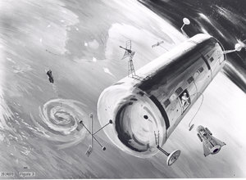

Manned Orbiting Laboratory early 1960 conceptual drawing that did not use the Gemini spacecraft.

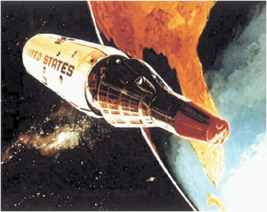

Gemini B reentry module separates from the MOL Laboratory. 1967 conceptual drawing using Gemini reentry spacecraft. (USAF)

The **Manned Orbiting Laboratory** (**MOL**) was part of the United States Air Force's manned spaceflight program, a successor to the cancelled X-20 Dyna-Soar project. It was announced to the public on the same day that the Dyna-Soar program was cancelled, December 10, 1963. Starting in 1965 a large optical system was added to the spacecraft. This camera system was codenamed **Dorian** and given the designation **KH-10**. Initially, the MOL was intended to prove the utility of man in space for military missions. However, the program was redirected in the mid-1960s and developed as a space station used for reconnaissance purposes. The space station used a spacecraft that was derived from NASA's Gemini program. The project was cancelled on June 10, 1969 before there were any operational flights. The contractor for the MOL was the Douglas Aircraft Company.

There was one test flight of an MOL mockup that was constructed from a Titan II propellant tank. The Gemini 2 spacecraft was re-flown on a 33-minute sub-orbital test flight. After the Gemini was separated for its sub-orbital reentry, the MOL mockup continued on into orbit and released three satellites. A hatch was installed in the Gemini 2 heat shield to provide access to the MOL and was tested in the sub-orbital reentry. The test flight was launched by the USAF on November 3, 1966 at 13:50:42 UTC on launch vehicle Titan IIIC-9 from LC-40 at Cape Canaveral, Florida. The Gemini 2-MOL space capsule was recovered near Ascension Island in the South Atlantic by the USS *La Salle*.

The MOL was going to have a helium-oxygen atmosphere. It used a Gemini B spacecraft as a reentry vehicle. The crew were launched with the Gemini B and MOL and returned to earth in the Gemini B. They would conduct up to 30 days of military reconnaissance using large optics, cameras, and side-looking radar.

When the MOL program was cancelled in June 1969, there were 14 MOL astronauts in the program. NASA offered those under 35 years of age the opportunity to transfer to the NASA astronaut program. Seven of the 14 MOL astronauts were younger than 35 and took the offer. They were Richard H. Truly, Karol J. Bobko, Robert Crippen, C. Gordon Fullerton, Henry W. Hartsfield, Robert F. Overmyer and Donald Peterson.

In response to the announcement of MOL the USSR commissioned development of its own military space station Almaz.

In 2005, two MH-7 training space suits from the MOL program were discovered in a locked room in the Launch Complex 5/6 museum at Cape Canaveral Air Force Station (Nutter).